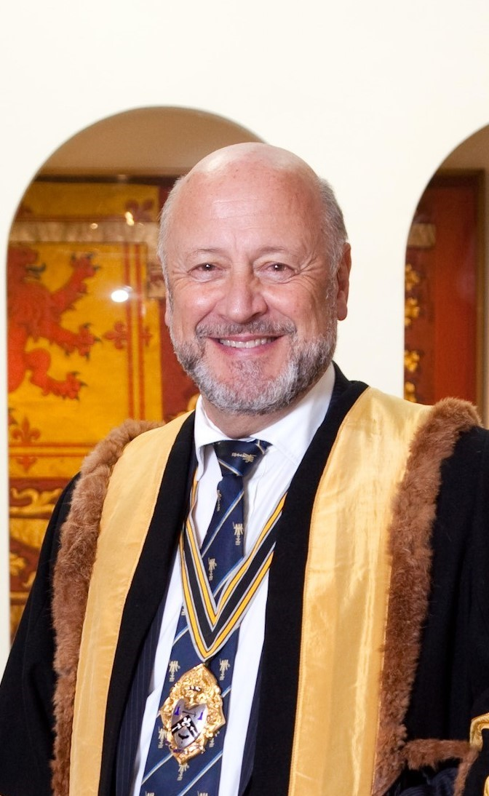

Air Commodore Paul Nash OBE BSc RAF (Ret’d)

Upper Warden Worshipful Company of Plumbers

Air Cdre Paul Nash served for 35 years in the Royal Air Force as a personnel officer. He undertook wide-ranging appointments at home and abroad within the RAF, in tri-Service appointments working with the Royal Navy and Army and in central policy appointments in MOD. These included duties as the facilities manager at the RAF’s main operating base in West Germany at the end of the Cold War, career manager for all junior personnel officers in the RAF, Chief Executive of the RAF’s operational base for its Jaguar aircraft, Director of Personnel Support for all military operations worldwide (for which he was awarded the OBE in the New Year’s Honours List 2001), Senior Personnel Staff Officer for the RAF, Head of the RAF Central Pay Policy Staffs in MOD and the Director for the development of all tri-Service pay, pension and personnel support for the Royal Navy, Army and RAF. He travelled extensively in support of and on operations in Europe, the Middle East, Central America and the South Atlantic.

He retired from the RAF in 2010 and took up the appointment as Clerk to the Worshipful Company of Plumbers until retiring from that at the end of 2016, when he was invited to join the Livery and then the Court of Assistants. He was asked to return as acting Clerk in 2018 and retired a second time a year later. He is the webmaster for the Company’s new website, which he helped develop, and was installed as the Renter (Junior) Warden in October 2019 and Upper Warden in October 2021. If elected he will serve as Master from October 2022 to October 2023.

Paul is married to Sue and has two grown-up daughters. He lives in Lincolnshire and his hobbies include golf, which he plays reasonably well and skiing, at which he is fairly accomplished!

